**upgrade**

Game Concept & Design Document Template

Table of Contents

1.1 credits 3

2 document 4

2.1 introduction 4

2.2 Game Analysis 5

2.3 Game Atmosphere 6

2.4 Game Play 7

2.5 Key Features 8

3 Design Document 8

3.1 Design Version 8

## credits

Jidske Donkers

Peije Steinz

Ahmed Lkabous

Sebastiaan Kappert

Sjoerd Jakobs

Yosha Langhuis

*document version : version 0.1*

*Working Title : Upgrade*

*Game concept : asteroids with upgrades*

*Game Document Author : Sebastiaan Kappert*

# document

## introduction

Upgrade is a single player top down shooter set in space.

The player has to destroy to score as much points as possible.

As the player destroy’s enemies they drop weapons which increase the effectivenes of the player’s guns.

## Game Analysis

|  |  |
| --- | --- |
| **Game Description** |  |
| Genre: | * Top down shooter |
| Game Elements: | *:*   * + Shooting   + Combat   + Dodging   + upgrading |

|  |  |
| --- | --- |
| Theme: | *:*   * + space   + Sci-Fi |
| Style: | * + Arcade   + Cartoony realistic |
| Game Sequence: | * *ope world // random generated* * *increasing difficulty* |
| Player: | * + Single player |
| **Game Reference** |  |
| Game Taxonomy: | * Upgrade is a fictional chance/simulation game |
| Player Immersion: | * + Tactical   + Strategy |

|  |  |
| --- | --- |
| **Game Technical** |  |
| Technical From: | * Flash 3d graphics rendered in 2d |
| View: | * Top down |
| Platform: | * Flash, actionscript 3, |
| Device: | * PC |

|  |  |
| --- | --- |
| **Game Sales** |  |
| Consumer Group: | * Teenager around 16 years old |
| Payment: | * This a good point to talk a person from marketing |
| Estimated Price: | * This a good point to talk a person from marketing |
| Device Support List | * See Appendix A |

## Game Atmosphere

The stye of the game will be cartoony realsitic.

Realistic made with a somewhat cartoony style without deriving to much from reality. The assets will not feature a outline.

See apendix A for more info

## 

## Game Play

You start by opening the game on kongregate.com (or other client of choice).

here the player selects their preffered options and can see the credits.

After this they can start a game and get right in the action and try to survive in the endless space scoring as many pointsa as possible by destroying the oncoming barrage of enemy ships. Where they will have to scavange weapons from destroyed enemies to increase their chances of survival in the next encounter, the player will feel like he is truly floating in soace ans such will have to adjust accordingly to be able to dodge enemy fire.

The game is over when the player’s ship is totaly destroyed.

This is makes the game fun beacuase of the constant choice of choosing dropped weapons and weighing your options with the ones you already have.

The threat of immenent enemies also encourges the player to keep playing and trying to beat them.

## Key features

* Endless space
* Single player
* 1 character
* Endless hours of gameplay beacause of the random elements
* Replay ablity is high because of the random elements once again
* PC flash game

## Selling feutures

* endless space
* scavanging enemy weapons
* choosing batttles carefully
* surviving in outer space

# design document

## design version

actionscript 3

concept version2

content update 1

## design guidelines

the game will stay cartoony.

(needs update)

## Game design definitions

The main menu will be comromised of several buttons

* Start Game
* Credits
* Exit game

the game play will feature the player flying around in space and scavanging enemy ‘s dropped weapons for use on himself (see 2.4 gameplay and appandix C)

the player is controlled using the WASD buttons to turn and move and the spacebar to fire the ships weapons

## Game matrix

Elements properties

|  |  |
| --- | --- |
| Player | hitD, pos, health |
| Enemy | hitD, pos, health |
| pickup | hitD, ID |
| shots | hitD, pos |
|  |  |

## Player elements

In game name code name

|  |  |
| --- | --- |
| Health | Health |
| Position | xPosPlayer,YposPlayer |
| upgrade | Upgrade :array |
| Velocity | Vy,vx |
| Rotation | rot |

### Pick ups

Pick ups are vital to the game, see appindix c for more information on the pick ups that are dropped after destroying certain enemies

## Heads Up Display

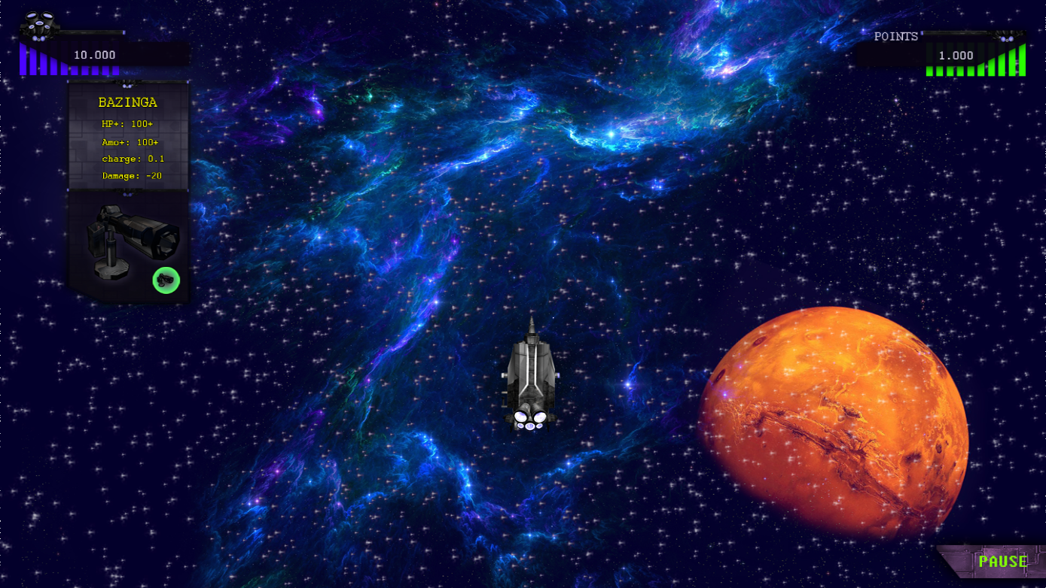

## Antoganistic list

* Several to be named enemies

## Arteficial Intelligence

The enemy spawns outside of the screen then proceeds to move to the cvicinity of the player.

When the enemy is in range a random movement fixated on the player start and the enemy opens fire

# Apandix A : styleboard

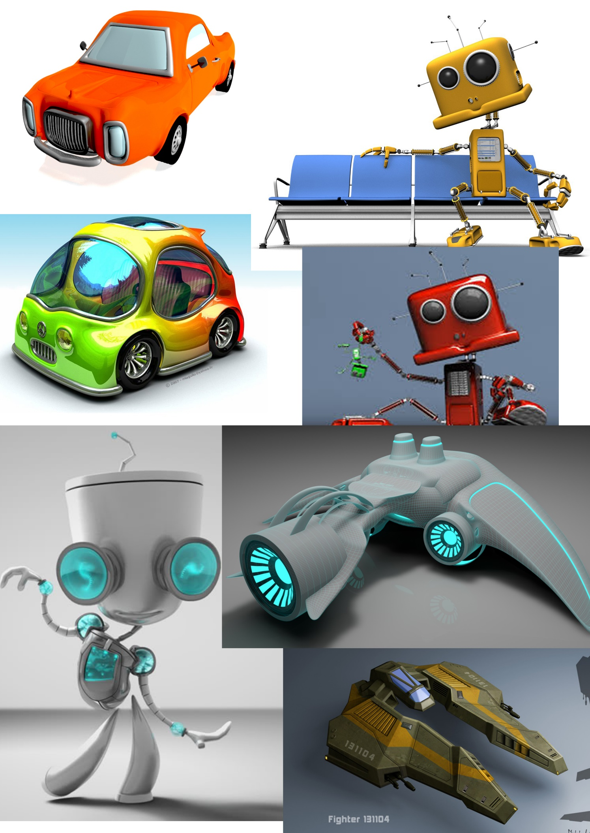

## 

# Apandix B : One page

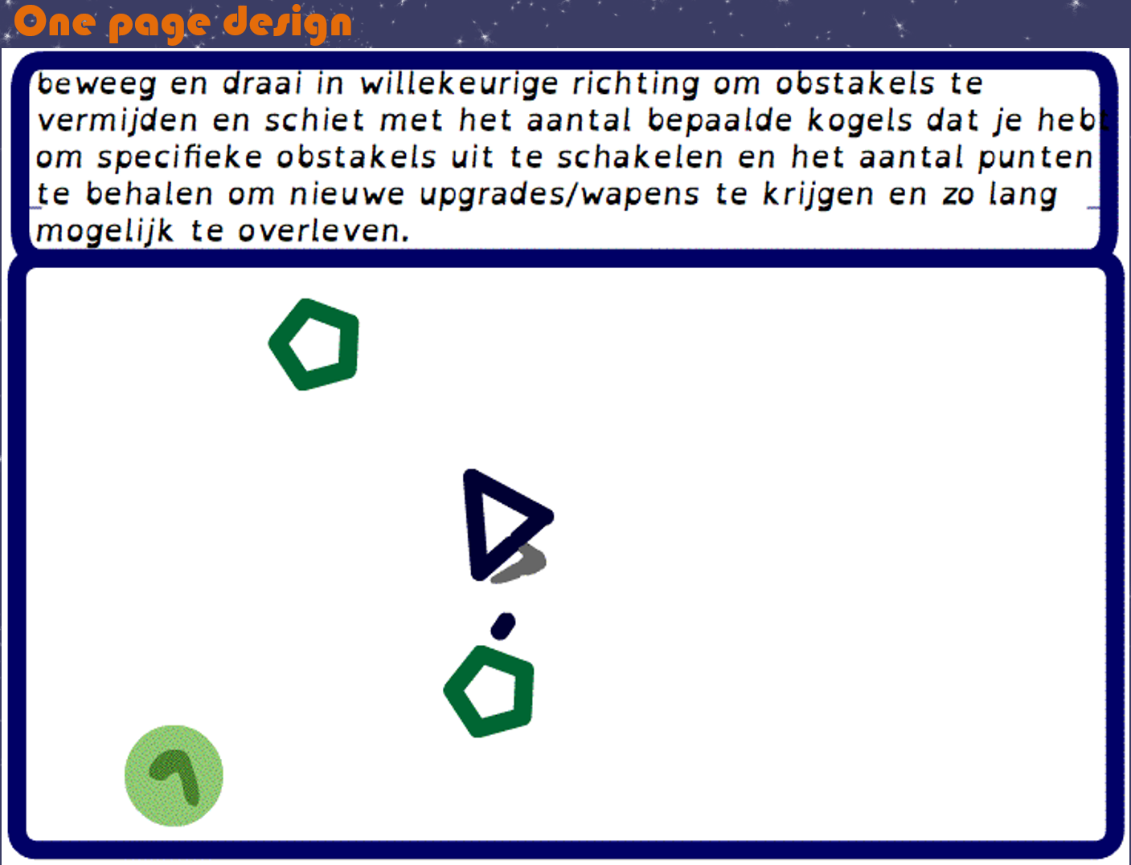

# Schermafbeelding 2015-05-12 om 20.13.43.pngAppendix c : weapons pick ups

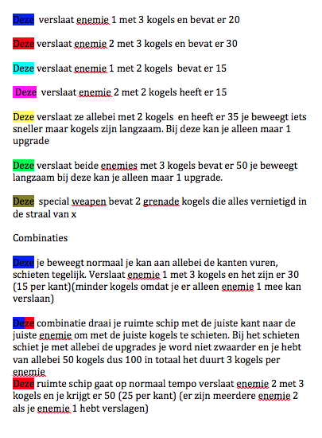

# Appendix D gant chart

